Mauthner Cells:

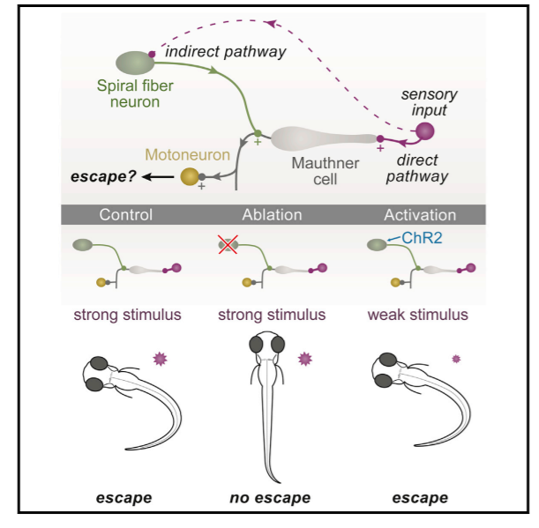

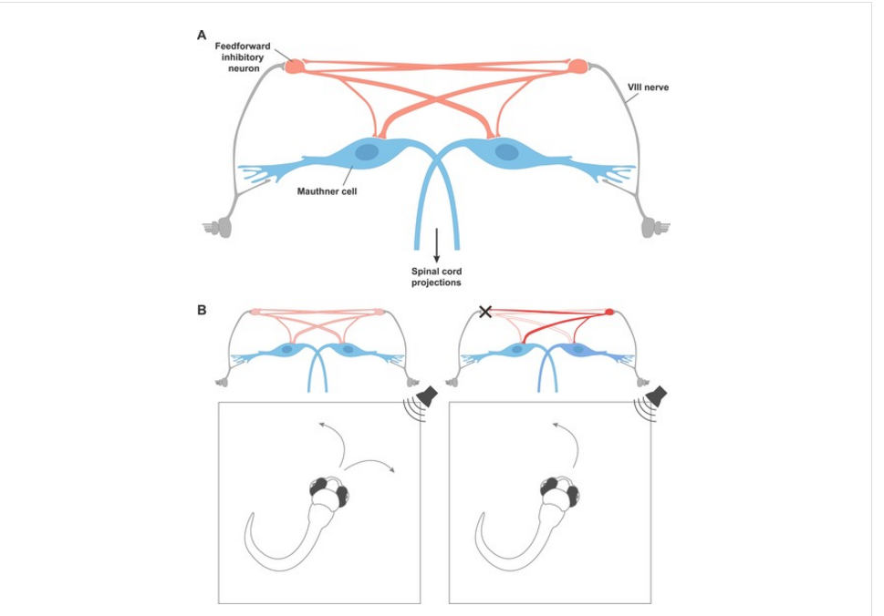

<https://elifesciences.org/content/5/e19351>

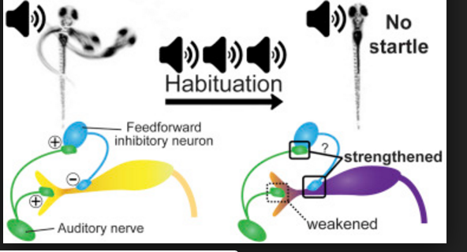

<http://www.cell.com/cell-reports/abstract/S2211-1247(15)01249-8>

Motor Circuit:

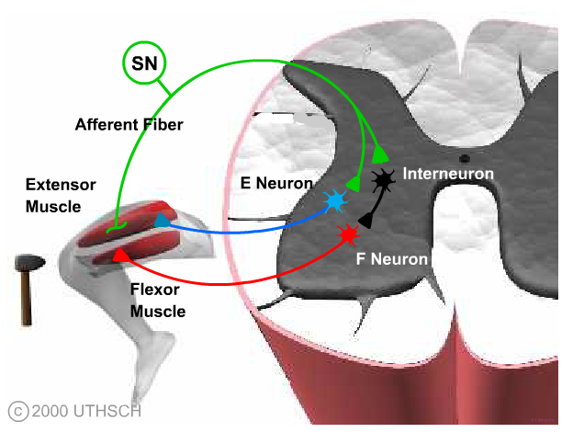

<http://nba.uth.tmc.edu/neuroscience/s1/introduction.html>

Retinal

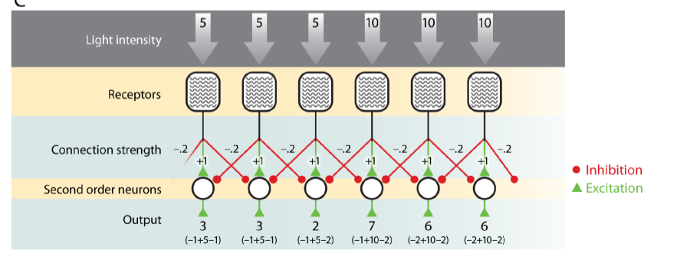

<http://nba.uth.tmc.edu/neuroscience/s1/introduction.html>